Zoé Turcaut ??
1818
Ste-Jeanne de Chantal Ile Perrot

https://familysearch.org/ark:/61903/3:1:3QS7-L993-W4XN?i=552&wc=9RL8-7M7%3A14284401%2C14284402%2C15320401&cc=1321742

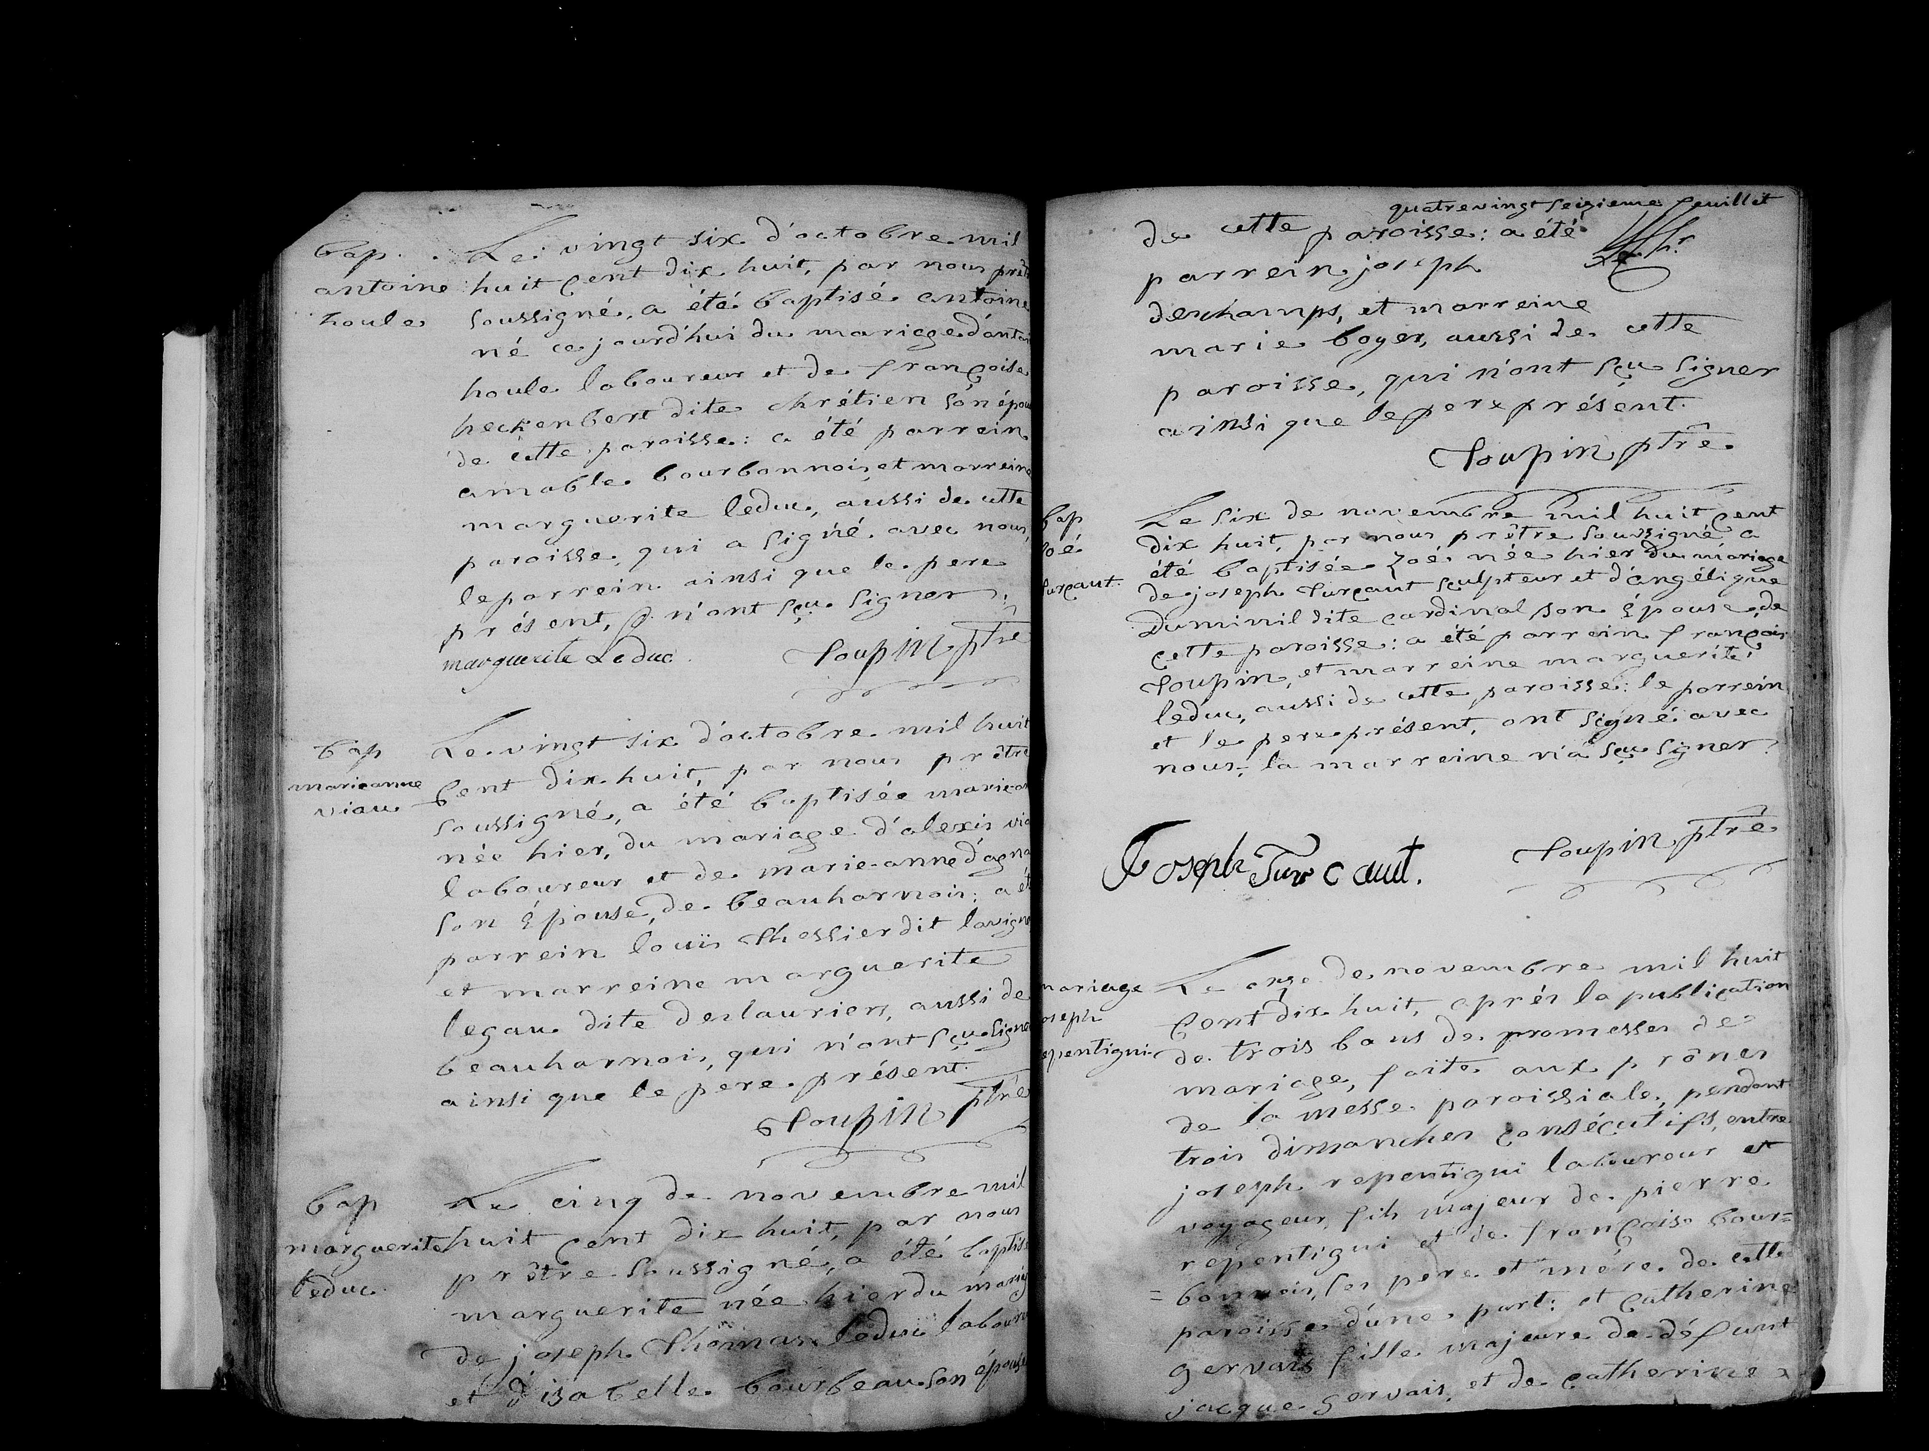

https://familysearch.org/ark:/61903/3:1:3QSQ-G993-WDYR?i=404&wc=9RLZ-FMQ%3A13625601%2C13625602%2C13625603&cc=1321742

